Weather Analysis

The data in this report was taken from 559 cities samples from the data set of cities found at [simplemaps.com/data/world-cities](https://simplemaps.com/data/world-cities). The current weather was found using the API at [openweathermap.org/](https://openweathermap.org/). The following graphs show trends in the weather compared to the latitude.

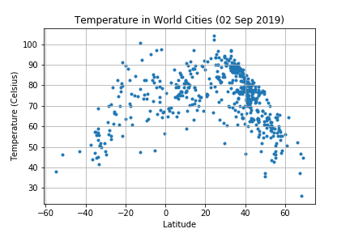

From the scatter plot we can see that there is a clear trend of cooler temperatures towards the poles and warmer temeperatures towards the equator. There appears to be a skew towards the north. This may be due to the seasonal change. Though it is autumn in the northern hemisphere the temperatures often lag behind the astronomical seasons. The city with the highest temperature is Medina which has a latitude of 24.47 and the temperature was recorded as 104 F.

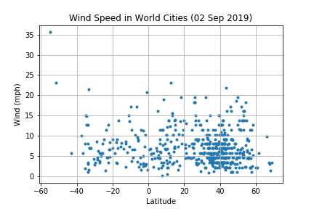

In the windspeed data there appears to be some outliers, notably Ushuaia which has a latitude of -54.81 and is considered to be the southern most city in the work. The windspeed is measures as 35.57 mph. This seems quite extreme however this may be expected due to the extreme location.

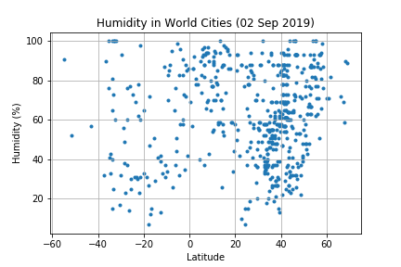

There isn't one clear trend with the humidity data however it is interesting to note that there is no city within 10 degrees of the equator that has humidity of less than 30%. There is a range of humidities at almost all latitudes though as you get above a latitude of 40 the humidity appears to increase.

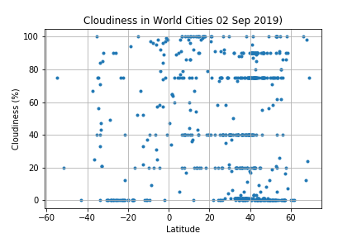

The data appears to be clustered here however it is important to note that some of this is due to the measuring techniques. in some regions the cloudiness is measured in oktas or eighths of the sky. This means that some measurements are more likely for example the cluster at 87.5% and 75%. It is notable that there are very few places at the equator with zero cloud. Most places with zero cloud have a latitude of around -20 or between 20 and 60.